1. Professional photo Sachin sir and a short history:

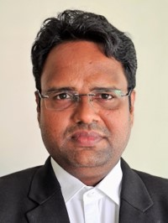 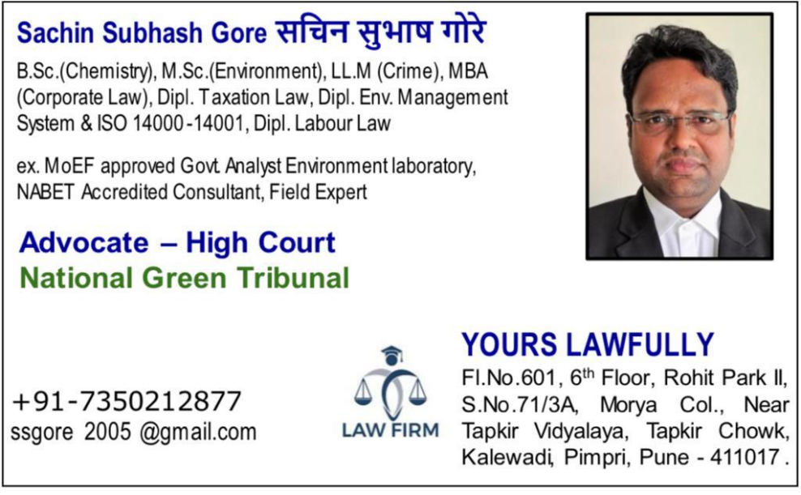

Short History:

>> Established on July 1, 2020, Yours Lawfully is a distinguished legal firm offering expert services across a broad spectrum of legal domains. We specialise in both civil and criminal law, providing robust legal representation and advice tailored to our client's unique needs.

Our firm has garnered a stellar reputation in the field of environmental law. We have extensive experience handling cases before the National Green Tribunal, Maharashtra Pollution Control Board (MPCB), Central Pollution Control Board (CPCB), and the Appellate Authority. Our legal expertise in environmental matters is complemented by our technical proficiency, enabling us to provide comprehensive support for various Environmental compliances and the acquisition of necessary NOCs/Consent/Clearance.

In addition to our legal services, we offer thorough environmental legal audits and consultations. Our audits are designed to ensure that our client's operations comply with all relevant environmental regulations, mitigating risks and enhancing sustainability.

At Yours Lawfully, our mission is to deliver exceptional legal solutions committed to excellence, integrity, and client satisfaction. Whether you need representation in a civil or criminal matter or require specialised environmental legal support, our dedicated team is here to assist you every step of the way.

1. Service list name:

|  |  |
| --- | --- |
| 1. Environmental Litigations 2. Civil Litigations 3. Criminal Litigations 4. Environmental Compliance Audit 5. Environmental Due Diligence | 1. Technical Legal support for Various Environmental NOC/Consent/ Clearance 2. Appeal before Appellant Authority 3. Presentation before MPCB/CPCB 4. Environmental Damages Assessment study |

1. Team Member names and photos:

>> Associated with various experts and Seniors on case to case basis

1. Phone PE or Google Pay QR code scanner



5. Client name and review around 4-5 (if interested)

>> More than 50 reputed clients from Industries and Building Construction Activity

6. Office Address

>> Adv. Sachin Subhash Gore,

A2, Kakade Aangan, opp. Talera Hospital, Tanajinagar, Chinchwad, Pune 411033

Location: <https://goo.gl/maps/ETeQdAGrjZH2>

>> Adv. Sachin Subhash Gore,

Flat no. 601, 6th floor, Rohit Park-II

Morya Colony, S.no. 71/3A, Near Tapkir Vidyalaya,

Opp. Tuljabhavani Mandir, Tapkir Nagar, Kalewadi,

Rahatani, Pimpri, Pune - 411017

Location: https://goo.gl/maps/YvjufMsZXML2

7. Phone Number

>> 7350212877

8. Social Media account link if interested

NA

9. Facebook:

NA

1. Twitter:

NA

1. Instagram:

NA

1. LinkedIn:

NA

Note: Details may change depending on the further consideration